# Manipulating the Current Date and Time - Exercise (Updated)

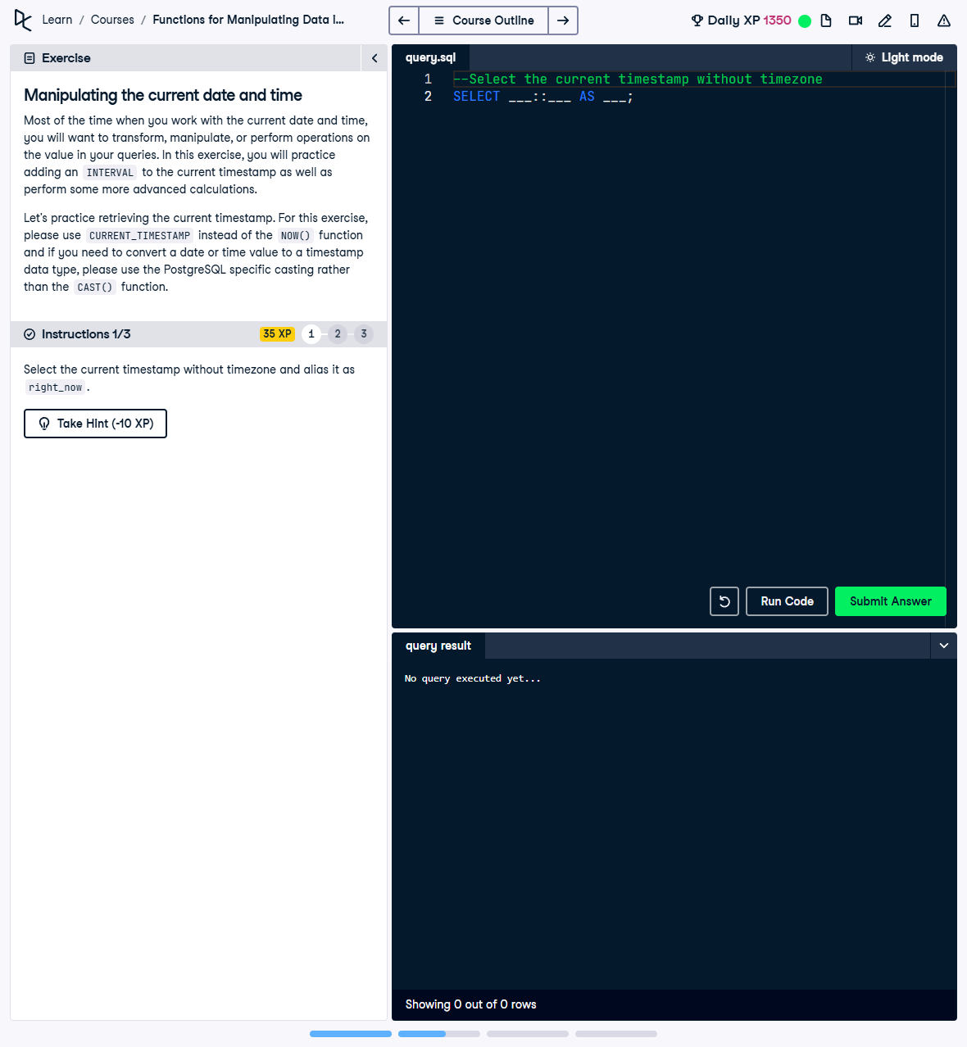

Question:

Select the current timestamp without timezone and alias it as 'right_now'.

## Answer:

-- Select the current timestamp without timezone and alias it as right_now  
SELECT CURRENT_TIMESTAMP::timestamp AS right_now;

## Explanation:

1. CURRENT_TIMESTAMP: Retrieves the current timestamp, including timezone information.  
2. ::timestamp: Casts the current timestamp to a type without timezone, removing the timezone information.  
3. AS right_now: Assigns an alias to the result for better readability in the output.